## **What are TestNG Reports?**

**TestNG Reports** are the default HTML reports which are generated once the test cases are executed using TestNG. These reports help you to identify the information about test cases and the status of a project. TestNG reports in Selenium have three methods: passTest, failTest, and skipTest to check the data about test cases.

Selenium web driver is used for automating the web-application, but it won’t generate any reports.

* The TestNG will generate a default report.
* When the testng.xml file is executed , a test-output folder gets generated for reporting in TestNG.

## **How to generate reports in Selenium**

### **Method-1: emailable-report.html**

1. Run the **testng.xml**
2. Go to **test-output** folder
3. Click on option “**emailable-report.html**”
4. Click on option web browser

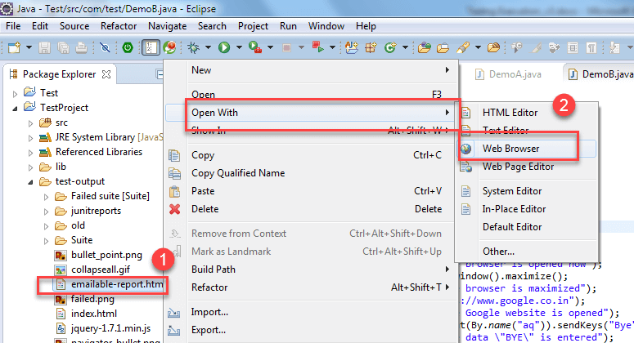

The output reports in TestNG reporting will look like below if both the classes are passed:

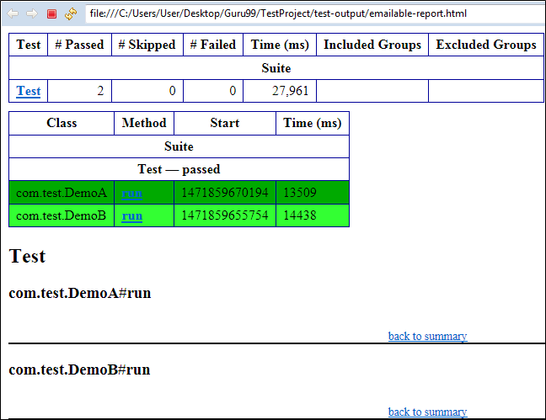

### **Method-2: index.html**

1. Right click on the index.html from the **test-output** folder
2. Select option open with web browser option. It will display the result in the following order.

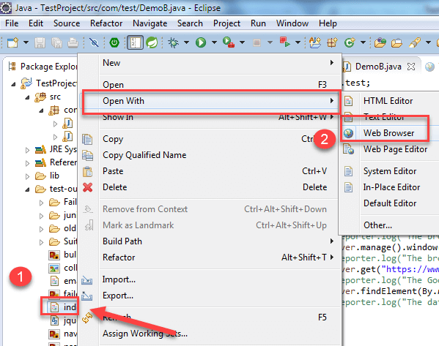

The result will look like this:

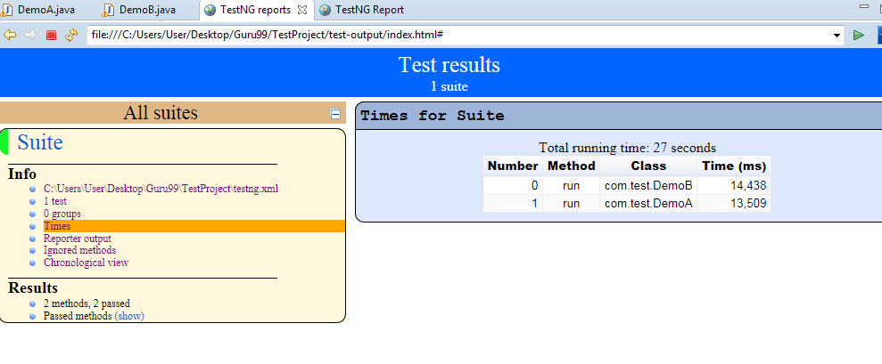

### 

### **Method-3: Reporter Class**

In addition to the above two approaches to induce reports, you can also employ the object.properties queue to store the system-generated logs as well as user-generated logs.

Reporter Class is one of the easiest ways to reposit log data in testing. Reporter class is an inbuilt class in TestNG. It helps in depositing the logs inside the reports, which are user-generated or system-generated so that in the future when you access the report, you can directly view the logs from there rather than rerunning the test cases.

Reporter is a class present in TestNG. It has four different approaches to storing the log information:

* **Reporter.log( String s);**
* **Reporter.log ( String s, Boolean logToStandardOut);**
* **Reporter.log ( String s, int level);**
* **Reporter.log ( String s, int level, Boolean logToStandardOut);**

**Example**:

Create Two classes such as DemoA and DemoB and write the following code inside the classes.

For Class DemoA;

* The Code for DemoA is already explained above. Here you are using the log **method of Reporter class.** (For implementing a reporting class, the class has to implement an org.testng.IReporter interface).
* The log method is a static method of Reporter class. So you are accessing that method through the Reporter class.
* The log method is used to store log information that is written inside the program. By looking at the log information, you will easily come to know where exactly the execution of the program is stopped.

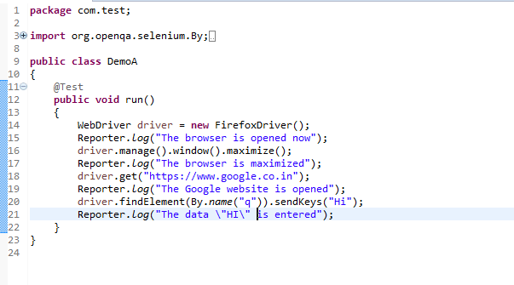

For Class DemoB:

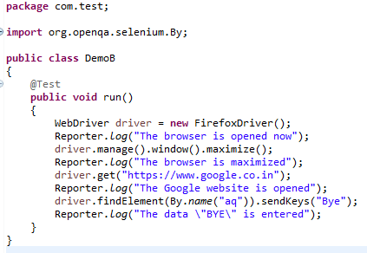

* Now, Create testng.xml file by selecting these two classes and
* Select run as and
* Click on the convert to testng.
* Then run this testng.xml file by selecting run as and select testng suite.
* Then refresh the project open the test-output folder.

1. In the test-output folder, open the emailable-report.html. It will look like:  
   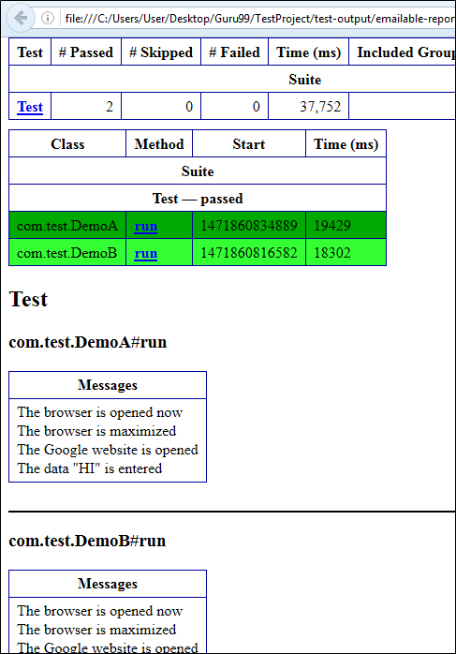

Similarly, you will have an Output for Demo B project as well.

2. In the test-output folder open the index.html. It will look like:

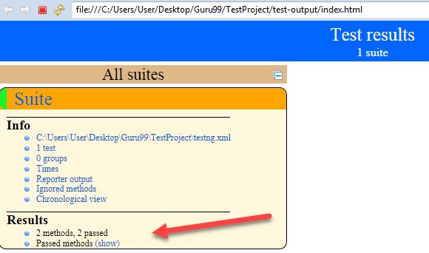

Click on reporter output. It will open logging info whatever written in the test methods.

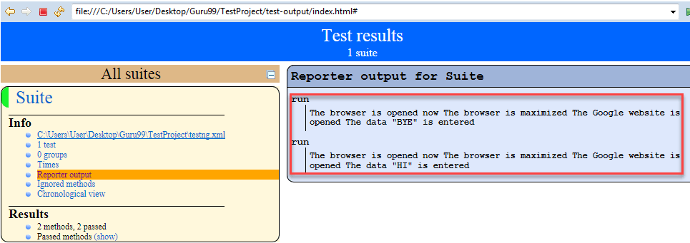

Click on the Times. It will going to show how much time it took to run the test method present in class using TestNG reporting tools.

